Function
______________________________________________________________________
Q. What is function?
___________________________________________________________________
Function is block of statement which is used for write some logics

Q. Why use function or what is benefit of function?
__________________________________________________________________________
1. Reusability of code: Suppose consider we have some task or some logics and we want to use it more than one time in same application or may be different application then we can write logic in function and reuse same function more than one time called as reusability

2. Modularity of code: We can divide the large task in to small functions and integrate them internally called as modularity

There are two types of functions
________________________________________________________________________
1. Built in function/ Library function: those functions provided by java to us called as built in functions.
like as nextInt(),nextLine() of Scanner functions is built or library function
2. User Defined functions: if user define own function and reuse it called as user defined functions.

How to create user defined function and use it
_______________________________________________________________________________
If we want to work with user defined functions in java we have two steps.
1. Define function: if we want to write logic then we need to define function
Syntax:
access specifier return type functionname(datatype variablename)
{ write here logics
}
Example:
public void add(int x,int y)
{ System.out.printf(“Addition is %d\n”,x+y);
}
Note: here public is access specifier and void is data type o return type and add is a function name
int x and int y is parameters
When we give void as function return type then we cannot return any value from function.

2. Call function: if we want to reuse function logic or code then we need to call it.
______________________________________________________________________________
Note: when we call function then function jump on its definition
Syntax: functionname(variablenames); or functionname(values)
Note: in calling function not need to pass data type just need to pass variable or constant values.
Example: we want to create function name as add with parameters and calculate addition of two numbers
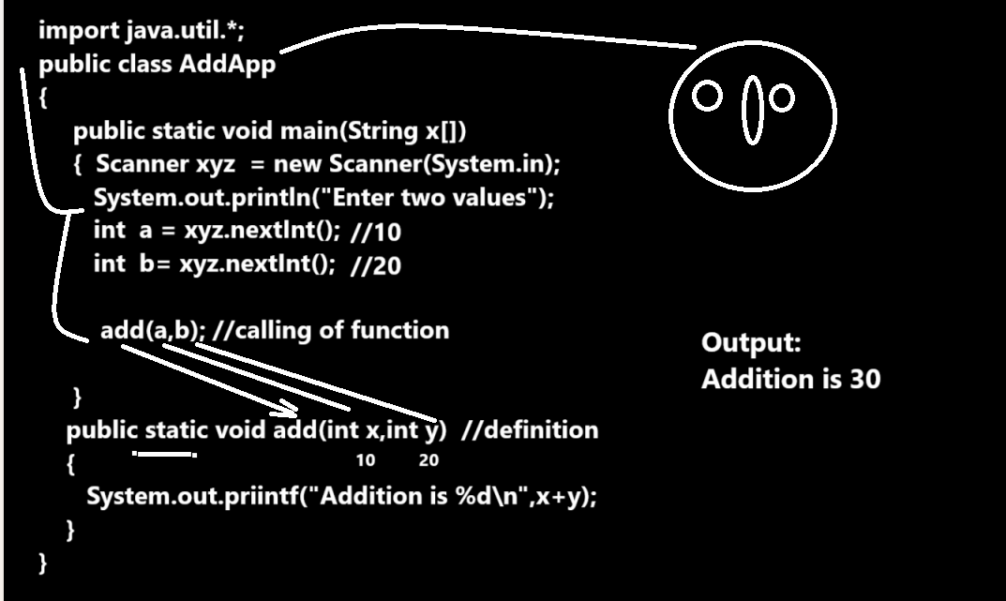
Example: WAP to create function name as void table(int x) this function can accept number as parameter and print its table.

import java.util.*;

public class TableApp
{
public static void main(String x[])
{
Scanner xyz = new Scanner(System.in);
int no,tab;
System.out.println("Enter number");
no=xyz.nextInt();
table(no); //calling
}
public static void table(int x) //definition
{
for(int i=1; i<=10; i++)
{
System.out.printf("%d\n",i*x);
}
}
}
Example: WAP to create function name as void power(int base,int index) and input two values and calculate its power using function
import java.util.*;
public class PPA
{ public static void main(String x[])
{ Scanner xyz = new Scanner(System.in);
int base,index;
System.out.println("Enter base and index");
base=xyz.nextInt();
index=xyz.nextInt();
power(base,index); //calling
}
public static void power(int base,int index) //definition
{ int p=1;
for(int i=1; i<=index;i++)
{
p = p * base;
}
System.out.printf("Power is %d\n",p);
}
}

How to return value from function
__________________________________________________________________
If we want to return some value from function definition to function calling we have to know the some important points.
1. Function return type should not void
2. Must be return keyword in function definition
3. When we return value from function then need to catch at calling point of function means need to use the variable at left hand side of function
4. Cannot write logic after return keyword
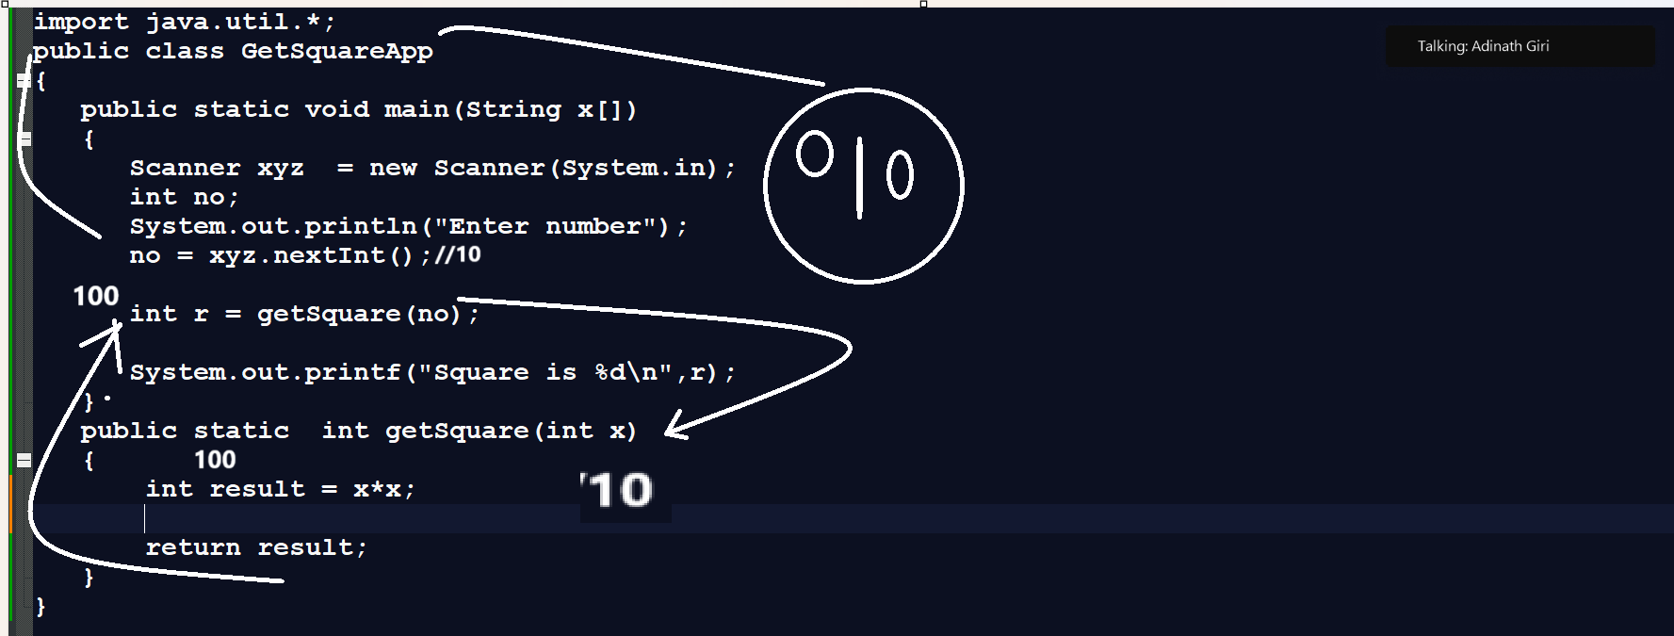

Example: WAP to create function name as int getFact(int) this function can accept number as parameter and calculate its factorial and return it.
import java.util.*;
public class FactFun
{
public static void main(String x[])
{
Scanner xyz = new Scanner(System.in);
int no,result;
System.out.println("Enter number");
no=xyz.nextInt();
result=getFact(no);
System.out.printf("Factorial is %d\n",result);
}
public static int getFact(int no)
{
int f=1;
for(int i=1; i<=no; i++)
{
f=f*i;
}
return f;
}
}

Function Recursion
_________________________________________________________________________
Function recursion means if we call same function from its own definition called as recursion
or
Function call itself again and again called as recursion
Generalize syntax of function Recursion
______________________________________________________________________________
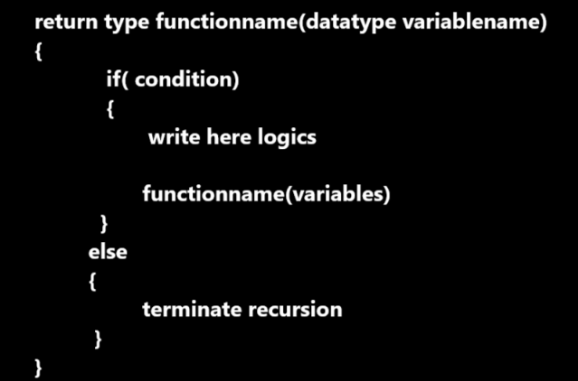
Example: WAP to print the good morning 5 times.

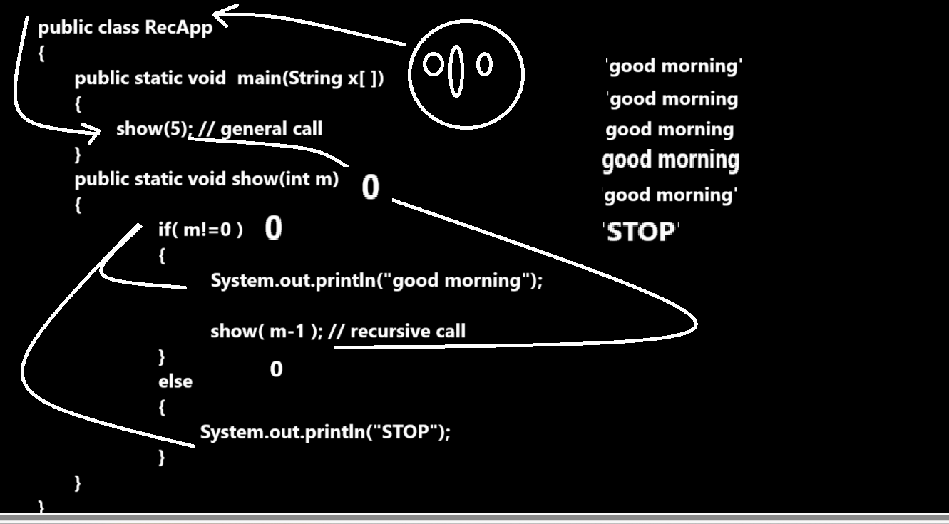
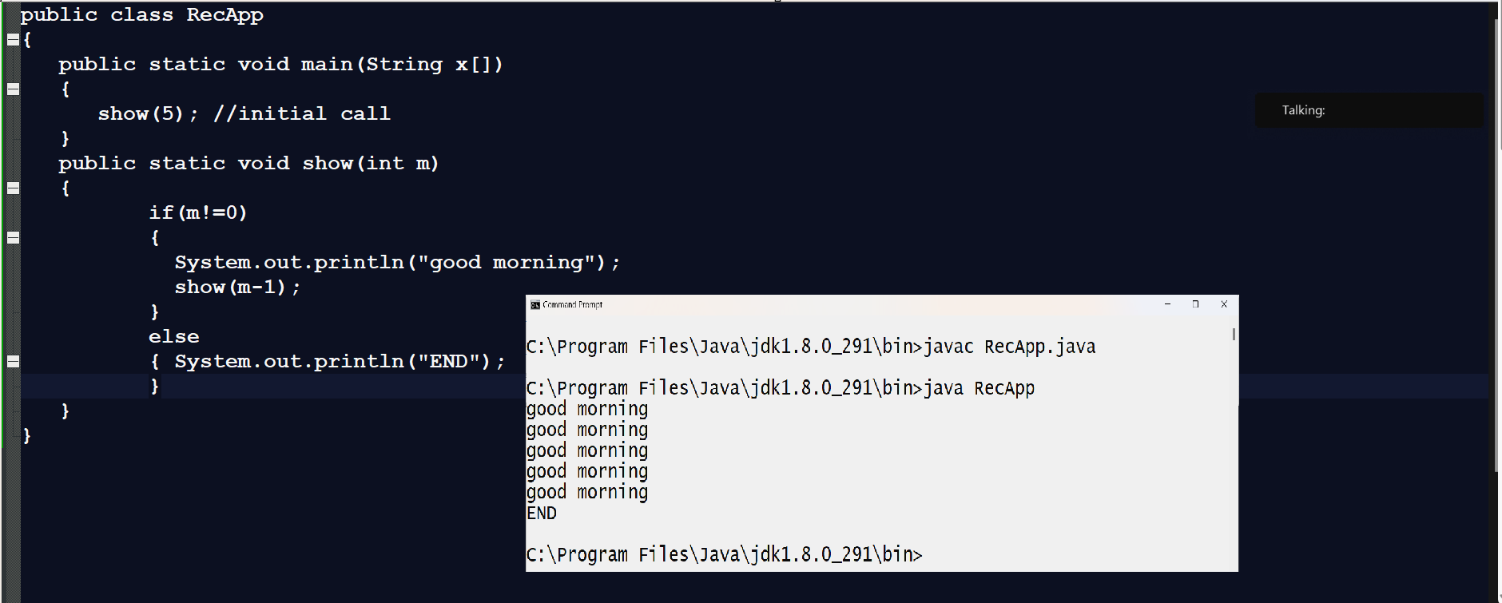

Example: WAP to input the number and print its table using recursion
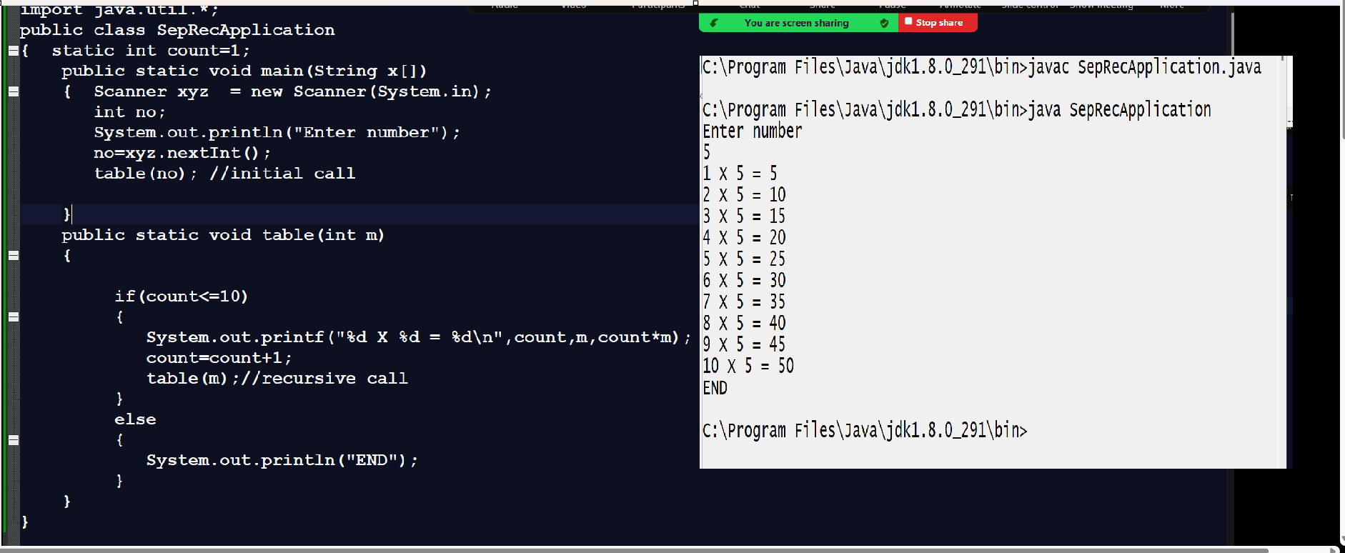
Example: WAP to create function name as power (int ,int) input the base and index value and calculate power of number using recursion
import java.util.*;
public class SepRecPowApp
{ static int p=1;
public static void main(String x[])
{
Scanner xyz = new Scanner(System.in);
int base,index;
System.out.println("Enter base and index");
base=xyz.nextInt();
index=xyz.nextInt();
power(base,index); //initial call

}
public static void power(int base,int index)
{

if(index!=0)//2!=0
{
p = p * base; //p= 1*5 = p=5

power(base,--index);//recursive call
}
else
{ System.out.println("Power is "+p);
}
}
}
Example: WAP to input number and reverse it using recursion
import java.util.*;
public class SepRevApp
{ static int r=0;
public static void main(String x[])
{ Scanner xyz = new Scanner(System.in);
int no;
System.out.println("Enter number");
no=xyz.nextInt();
int result= revNum(no);
System.out.println("Reverse number "+result);

}
public static int revNum(int no) //12
{
if(no!=0) //1!=0
{
int rem = no % 10; //rem=2
no = no /10; //no=1
r=r*10+rem; //r =30+2
revNum(no);
}
return r;
}
}

Example: WAP to input number and calculate its factorial using recursion

import java.util.*;
public class SepRevApp
{ static int f=1;
public static void main(String x[])
{ Scanner xyz = new Scanner(System.in);
int no;
System.out.println("Enter number");
no=xyz.nextInt();
int result= revNum(no);
System.out.println("Factorial of number "+result);
}
public static int revNum(int no) //12
{
if(no!=0) //1!=0
{
f=f*no;
revNum(--no);
}
return f;
}
}

Example: WAP to create function name as int getCount(int)
This function can accept the number as parameter and count number of digit from it and return it.
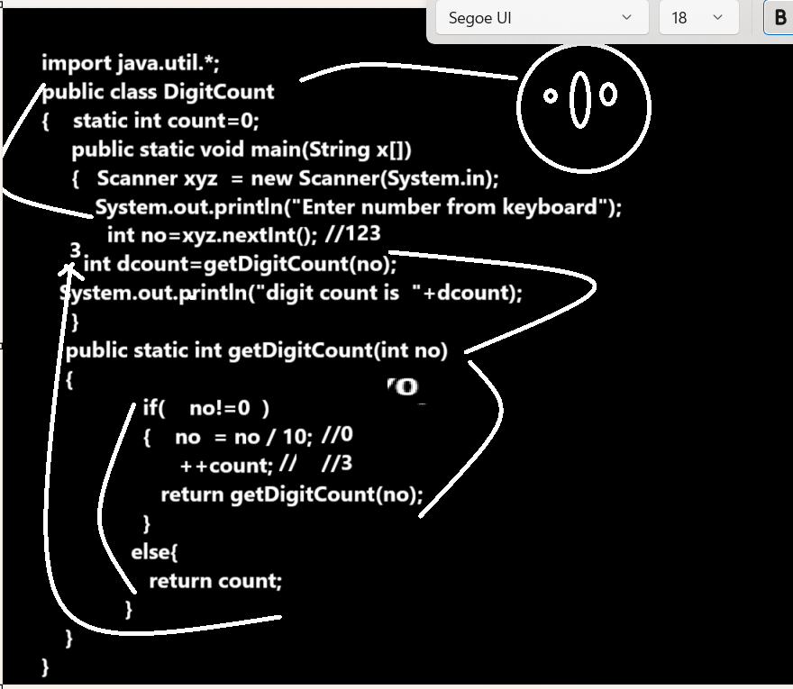

Example with source code
import java.util.*;
public class CountDigitApp
{ static int count=0;
public static void main(String x[])
{ Scanner xyz = new Scanner(System.in);
System.out.println("Enter number");
int no=xyz.nextInt();
int dcount=getCount(no);
System.out.println("Number of digit is "+dcount);
}
public static int getCount(int no)
{
if(no!=0)
{ no = no /10;
++count;
return getCount(no);
}
else
{return count;
}
}
}

Example: WAP to create function name as boolean checkPerfect(int no):
This function can accept number as parameter and check number is perfect or not if number is perfect return true otherwise return false.

import java.util.*;
public class CheckPerfectApp
{ static int i=1;
static int sum=0;
public static void main(String x[])
{ Scanner xyz = new Scanner(System.in);
System.out.println("Enter number");
int no=xyz.nextInt();
boolean result= isPerfect(no);
if(result)
{ System.out.println("Number is perfect");
}
else{
System.out.println("Number is not perfect");
}
}
public static boolean isPerfect(int no)
{
if(i<no)
{
if(no%i==0)
{ sum= sum+ i;
}
++i;
return isPerfect(no);
}
else{
if(no==sum){
return true;
}
else{
System.out.println("Sum is "+sum);
return false;
}
}
}
}

